January 2022
Year 10 Work Experience- 27th June – 1st July

Dear parent/guardian,

At BGN we try to have a particular focus on careers and future plans in Year 10. Last term, during form time, Year 10 were working through booklets thinking about their employability skills and creating their CVs.

For the last two years, due to the pandemic, we have been unable to run face-to-face work experience for year 10 students. However we are delighted to say that we plan for it to take place this year, in the summer term Monday 27th June to Friday 1st July. We appreciate that students may find it difficult to find placements this year so please see attached an extensive list of local employers who have previously accepted students for work experience. It is not a guarantee that these companies will accept students, but it is worth a try. Students who do not secure a placement will remain in school during this week.

Once students have found a placement, they should complete the attached form which needs to be signed by the employer and parents. This form should be returned to Mrs Russell in the LRC by Monday 25th April. The form can be returned as a physical copy or emailed to Mrs Russell- RRussell@bgn.oxon.sch.uk

In preparation for their work experience all Year 10 students will have a mock interview either on 8th or 10th February. This interview will either be with a member of the senior leadership team from school or a local employer. It is an opportunity for students to show off their CVs and have a chat about their plans for work experience and beyond. Students will be told of their specific appointment time by their form tutor.

If you think you or your employer would be able to offer a placement for one of our students then please do let me know.
If you have any questions then please contact me.

Kind regards,

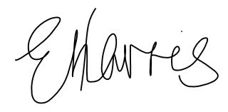
Mrs Harris- Careers Lead

